**IBM CLOUD ACCOUNT**

Create and login to IBM Account.

**Link:** [IBM Cloud Account Creation](https://cloud.ibm.com/registration)

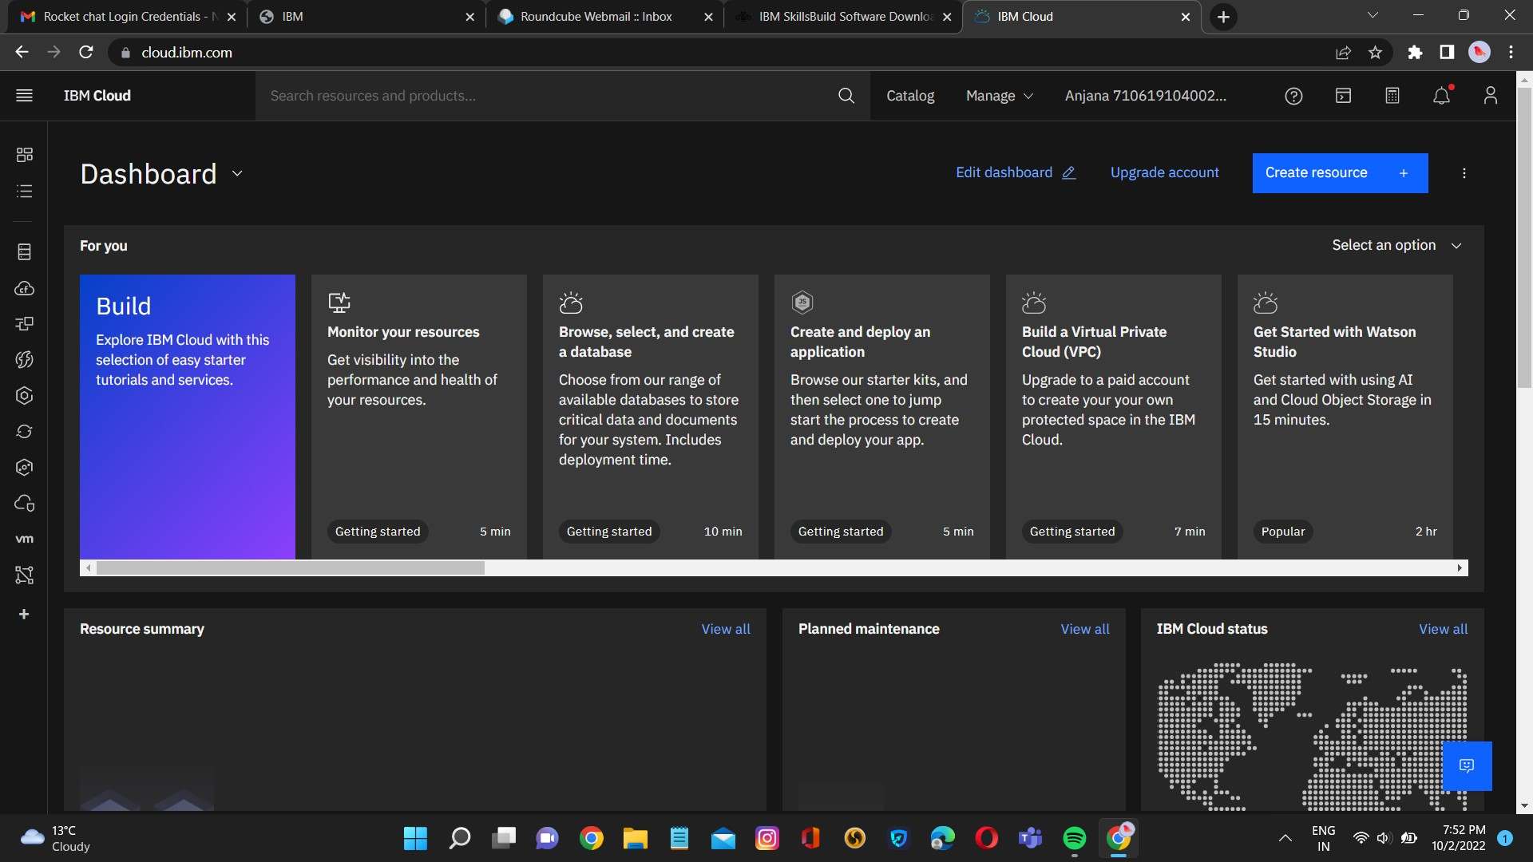

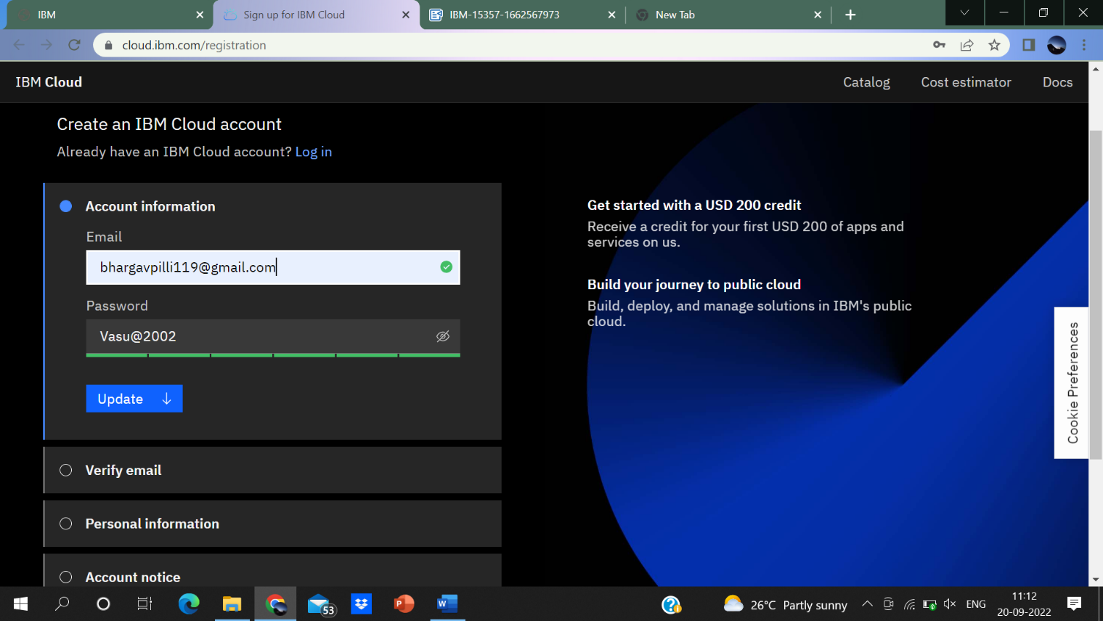**Creation of cloud account is successfully completed.**